**PRACTICAL: 01**

**Study Of Android and Installation of Android Studio**

**Study of Android:**

**Android**is the best-selling **Operating System** among various mobile platforms across the globe. Hundreds of millions of mobile devices are powered by **Android** in more than 190 countries of the world. It conquered around **75%**of the global market share by the end of 2020, and this trend is growing bigger every other day.

**ANDROID FRAMEWORK**:

**Application Framework:**

The Application Framework layer provides many higher-level services to applications in the form of Java classes. Application developers are allowed to make use of these services in their applications.

The Android framework includes the following key services −

* **Activity Manager** − Controls all aspects of the application lifecycle and activity stack.
* **Content Providers** − Allows applications to publish and share data with other applications.
* **Resource Manager** − Provides access to non-code embedded resources such as strings, color settings and user interface layouts.
* **Notifications Manager** − Allows applications to display alerts and notifications to the user.
* **View System** − An extensible set of views used to create application user interfaces.

**INSTALLATION OF ANDROID STUDIO:**

**Step 1:**search on google android studio download

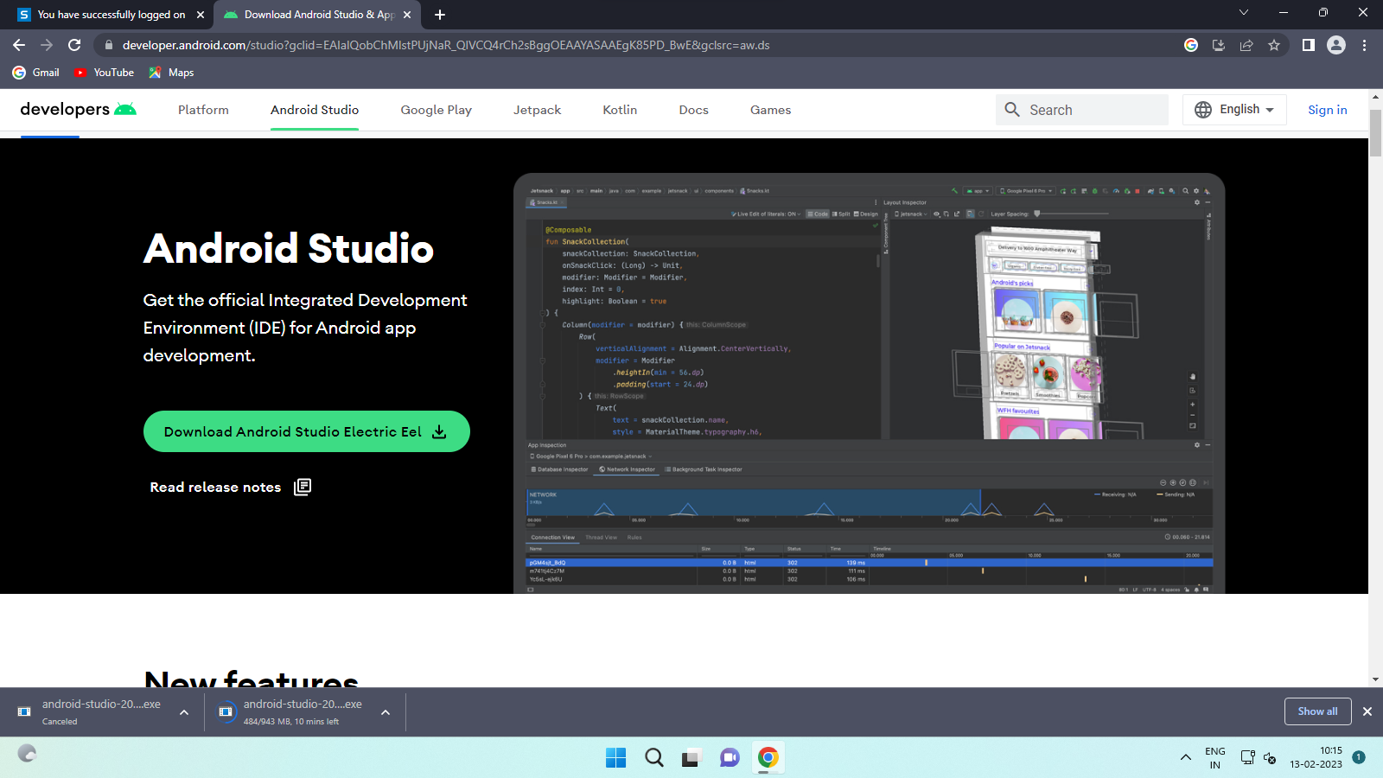

**Step 2:**Click on the DownloadAndroidStudio Button.

Click on the “I have read and agree with the above terms and conditions” checkbox followed by the download button

**Step 3:**After the downloading has finished, open the file from downloads and run it. It will prompt the following dialog box.

**Step 4:**It will start the installation, and once it is completed, it will be like the image shown below.

**Step 5:**Once “**Finish**” is clicked, it will ask whether the previous settings need to be imported [if the android studio had been installed earlier], or not. It is better to choose the ‘Don’t import Settings option’.

Click the OKbutton.

**Step 6:**This will start the Android Studio.

**Step 7:**After it has found the SDK components, it will redirect to the Welcome dialog box.

Click on Next.

Choose Standard and click on Next. Now choose the theme, whether the Lighttheme or the Darkone. The light one is called the IntelliJtheme whereas the dark theme is called Dracula. Choose as required.

**Step 8:**Now it is time to download the SDK components.

Click on Finish. Components begin to download let it complete.

The Android Studio has been successfully configured. Now it’s time to launch and build apps. Click on the Finish button to launch it.

**Step 9:**Click on Start **a** newAndroidStudioproject to build a new app.

**Hello World Practical**

**activity_main.xml**

<?xml version="1.0" encoding="utf-8"?>

<android.support.constraint.ConstraintLayout xmlns:android="http://schemas.android.com/apk/res/android"

xmlns:app="http://schemas.android.com/apk/res-auto"

xmlns:tools="http://schemas.android.com/tools"

android:layout_width="match_parent"

android:layout_height="match_parent"

android:minWidth="@android:dimen/app_icon_size"

app:barrierMargin="@android:dimen/notification_large_icon_width"

tools:context=".MainActivity">

<TextView

android:layout_width="wrap_content"

android:layout_height="wrap_content"

android:text="Hello Word"

app:layout_constraintBottom_toBottomOf="parent"

app:layout_constraintEnd_toEndOf="parent"

app:layout_constraintStart_toStartOf="parent"

app:layout_constraintTop_toTopOf="parent" />

</android.support.constraint.ConstraintLayout>

**MainActivity.java**

package com.example.lab_1_textview;

import android.support.v7.app.AppCompatActivity;

import android.os.Bundle;

public class MainActivity extends AppCompatActivity {

@Override

protected void onCreate(Bundle savedInstanceState) {

super.onCreate(savedInstanceState);

setContentView(R.layout.activity_main);

}

}

**Output**:

